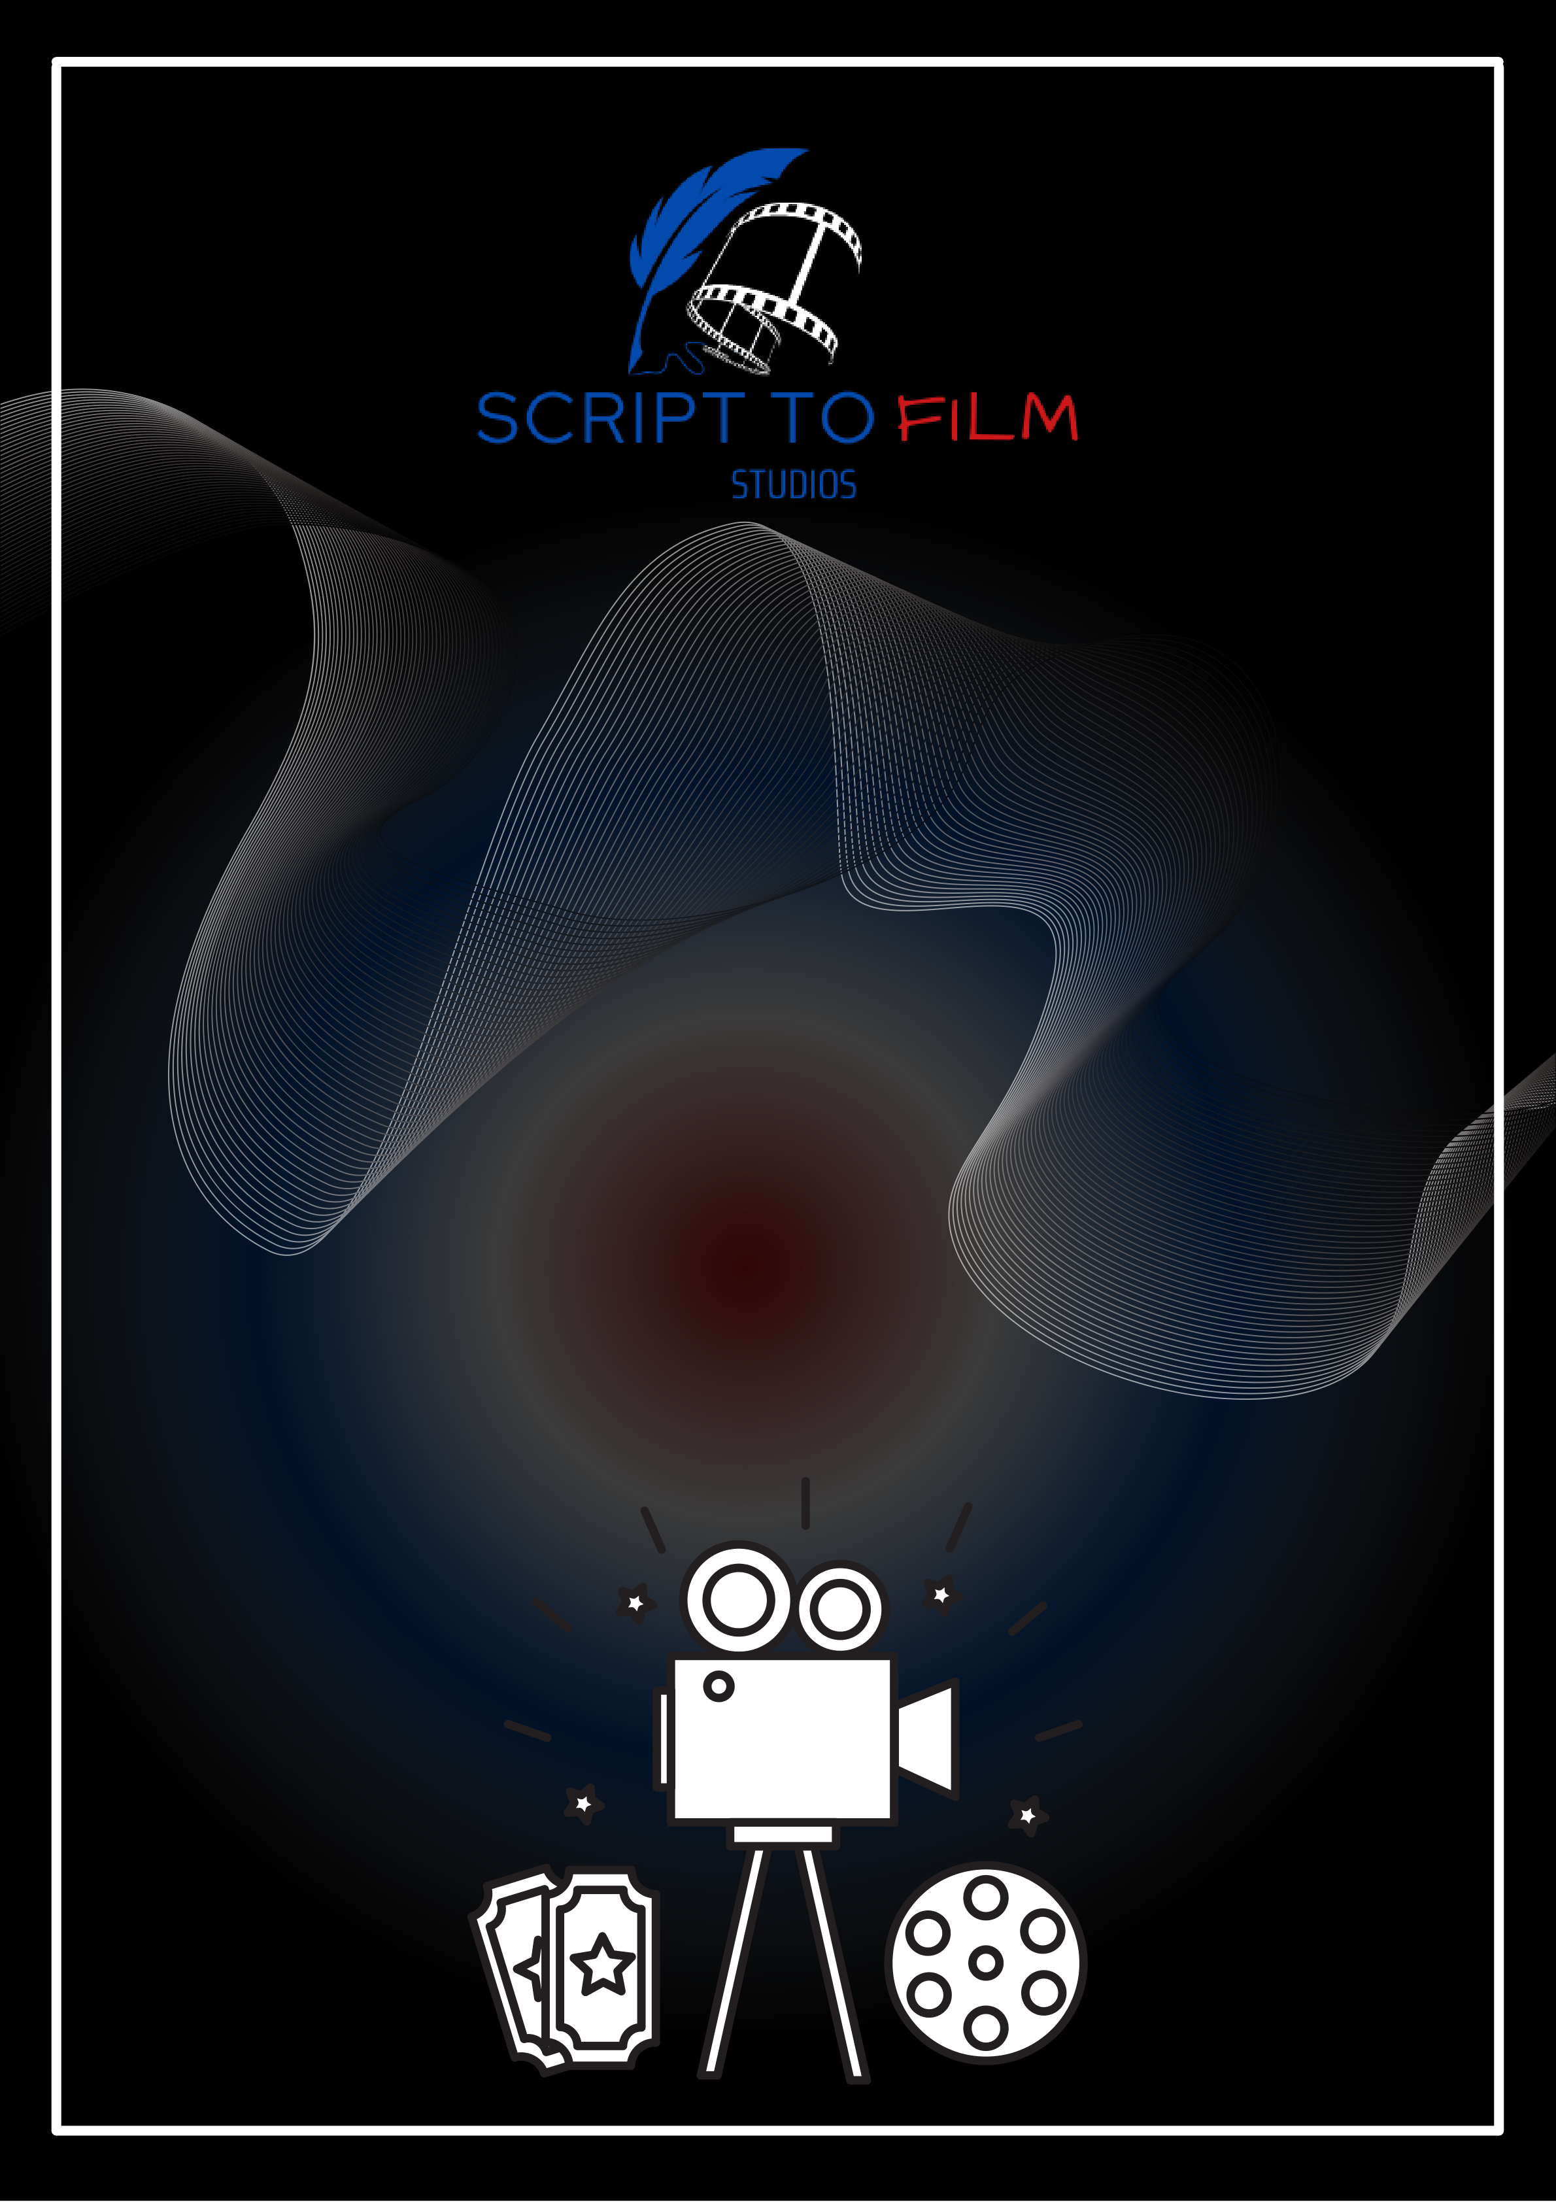

B A S I C S O F  
 F I L M S E T   
T E R M I N O L O G Y

|  |  |  |
| --- | --- | --- |
|  | |  | | --- | | B a s i c s o f F i l m S e t T e r m i n o l o g y | |

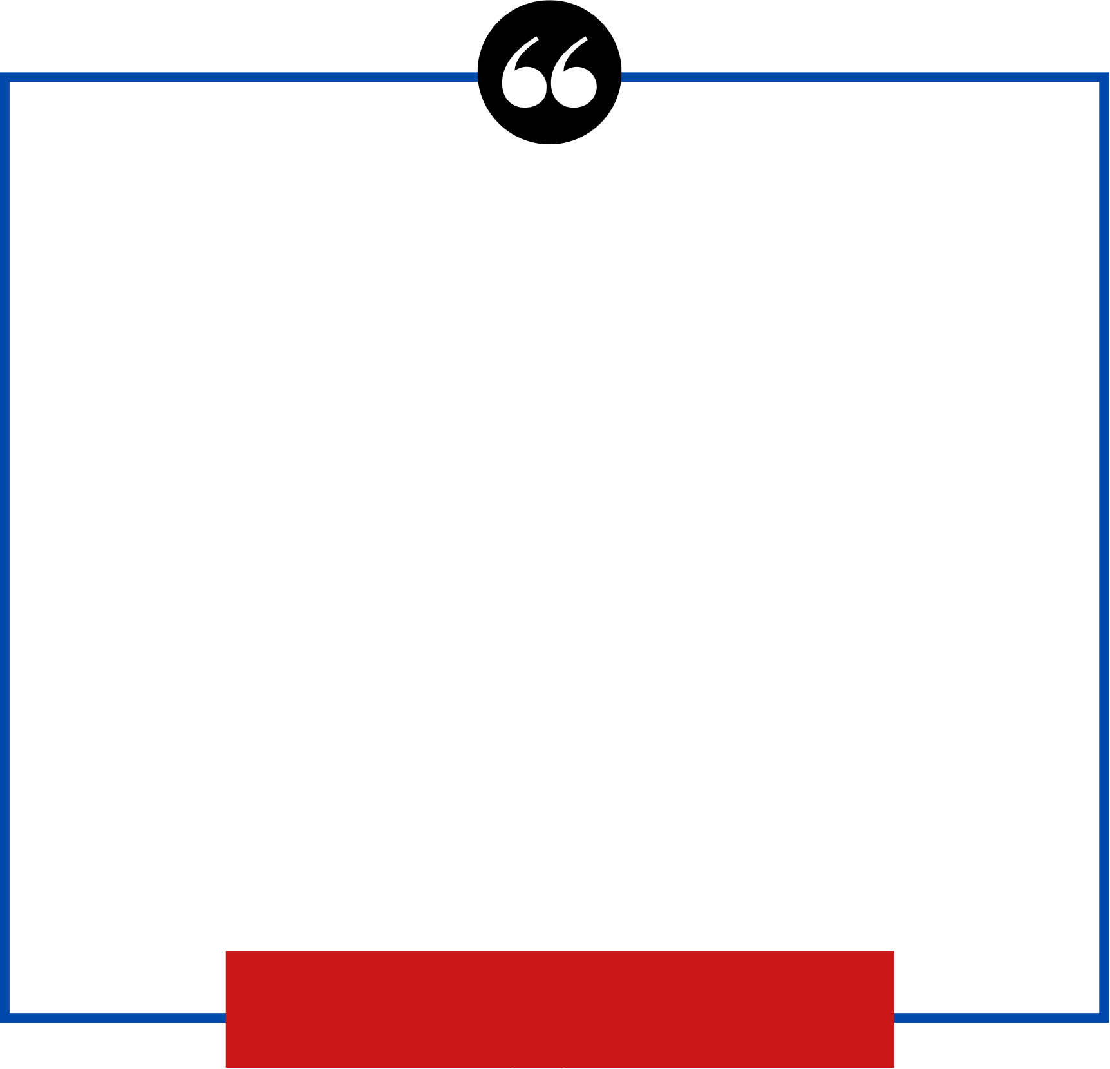

|  |
| --- |
| **Learning Your Crew or Teammates** |

Elia Kazan, the famous stage and film director, said to me when I started my directing career that 80 percent of this business is the ability to get along with other people. Not talent, not   
brilliance, not who you know, but the ability to get along with other people.

Milton Katselas, *Dreams into Action*

|  |
| --- |
| Page-1 |

|  |  |  |
| --- | --- | --- |
|  | |  | | --- | | B a s i c s o f F i l m S e t T e r m i n o l o g y | |

Crew members are your teammates. They can make you look good or bad. I am not saying you have to be nice to everyone, but some understanding of what these people do may help you to help them help you. They want you to look your best, so keep that in mind while you are working with them.

This is a basic rundown of each hat on set. Check the internet to find out more about what each department does.

The **producer**usually does the hiring and firing, rounds up the crew and the equipment, and handles details like the deal memos. He is responsible for the budget and for making sure the movie gets made on time and within budget.

The **director**works with the actors to get the desired performances from them. The director also coordinates with the director of photography and the assistant directors to make sure they get accurate shots on time. Depending on the budget and the arrangement, directors may have the power to make the movie the way they like or they may have to report everything they are doing to producers. Directors want everything to go well and specifically as they envision, so if you have questions about the script, they are the people to see.

The **writer**writes the script and sometimes has a lot of power on the set, so it is a good idea to follow the script as closely as possible. If you are allowed to improvise, you can do it. But if you have a problem with the script, talk to the director and/or the writer before filming so you have time to work it out before you are on set and in front of a crew that is being paid a lot of money to be there. Talking to the writer can be tricky, but if the writer and the director are okay with it, this might help you get further insight into your character. But don’t use a conference with the writer as a way to gang up on the director. He usually has the final say.

The **director of photography** (DP) films the movie. He works with the director to design the shots and to make sure the camera crew sets up the lights and the camera properly for each shot.

The **gaffer**is the head electrician and works with the DP to light the shots the way the DP and the director want.

The **grip**sets up the stands and the rigs to hold the lights for the electricians.

|  |
| --- |
| Page-2 |

|  |  |  |
| --- | --- | --- |
|  | |  | | --- | | B a s i c s o f F i l m S e t T e r m i n o l o g y | |

The**first assistant director**schedules the shooting and organizes when and where people are supposed to be. First assistant directors keep the set moving and people working on the next set- up (the scene to be shot). They have a lot of responsibility and usually are fired if the set has not completed the schedule for the day. They also create the schedule at the start of filming and work to ensure the movie will be finished in the scheduled number of days.

The **second assistant director** carries out the orders of the first assistant director. Second ADs work with the background on placement and movement, and they file production reports at the end of each day that tell the producers how filming is going. On lower budget films they may also have to keep track of the main actors so the first AD can have the actors come to the set when the director is ready for filming.

The**production assistant** (PA) helps producers and directors and all the departments on set. PAs do everything needed on set including getting coffee and snacks for people. They buy missing items and take care of background, paperwork, and check-ins. They work extremely hard and get paid very little, sometimes even less than union background.

The **script supervisor** (script) is in charge of continuity, which means an uninterrupted flow. Script supervisors make the film make sense. They write out notes for the editor to cut the movie together. This makes it possible for the assistant editor to find footage and the sound that matches it and to sync them together. They also pay attention to what the actors are wearing and to the props the actors are using and make sure they match from shot to shot. This is called matching. They also help the DP keep track of screen direction. This is known as continuity of filming or uninterrupted flow. Screen direction keeps the audience interested in the film. If screen direction is broken for even a fraction of a second, the audience may stop watching the movie. You do not want your audience to drift away. On a big budget film the editor will call for reshoots since distributors won’t pick up a movie if screen direction is broken. Screen direction is the direction in which the actors move or in which they are looking. I will provide more detail about this later in the book. Script supervisors work with every department on set to ensure the film makes sense to the audience and can be cut together. This job is a great launching pad for becoming a director, an editor, a writer, a producer, an actor, or any other employee on a movie set because script supervisors work with everyone, know what everyone is doing, and make sure everyone is working in sync with each other and with the script. This allows the director to focus on working with the DP and with the actors to pursue his or her vision.

The **camera operator** (camera op) runs and carries the camera.

|  |
| --- |
| Page-3 |

|  |  |  |
| --- | --- | --- |
|  | |  | | --- | | B a s i c s o f F i l m S e t T e r m i n o l o g y | |

|  |
| --- |
| **A list of some words you will hear on sets** |

1. Post means editing a common term not favored on sets is “fix it in post”

2. Call Sheet is a term used for a piece of paper which has all the information of what is being shot that day and the time to be on set.

3. Slate is the [clapping](https://filmactlove.com/a-list-of-some-words-you-will-hear-on-sets/) board that has the scene number, take number, the camera roll number, and the director and production name on it. It is used to sync the sound and the picture of the film and to id shots without sound. It is very important for editing and finding footage.

4. Call time is the time the a person is supposed to arrive on set sometimes each person has a different call time or the crew all has the same call time. It is good to find your name on the call sheet and check your time next to it.

5. Mos means without sound. It is a European term coined many years ago.

6. Sticks means tripod and also sometimes when it is called out as second sticks that they actually are doing a second marker for the camera

7. B roll means footage not to be used in the film. Sometimes it is improperly used as [footage](https://highlinker.com/) shot on b cam.

8. PU shot or pick up shot means if you don’t move the camera or change the lens but you start later on in the scene and you have already shot that portion of the scene.

9. Slug line is usually a one line description of the scene.

10. A strip board is a list of slug lines and scenes in order of shooting the film. It is basically a schedule for the shoot.

11. Mark means two things mark means calling out the scene and take number on the slate and clapping it. It also means a piece of tape or a chalk mark on the floor for the actor to stand or walk too. It also sometimes is a piece of tape or mark on the wall or near the camera for the actor to look at.

12. Points means someone is carrying an object and they would like you to move out of their way.

13. 10-1 means using the restroom.

14. Rolling means they are shooting.

15. Pictures up means the assistant director is about to call roll sound and then roll film so be quite and finish up your work.

|  |
| --- |
| Page-4 |

|  |  |  |
| --- | --- | --- |
|  | |  | | --- | | B a s i c s o f F i l m S e t T e r m i n o l o g y | |

16. Cut means stop filming not really a great idea to start talking.

17. Video Village is the place where all the directors’ chairs are set and the monitors to view the scenes being shot. Be respectful and keep quite there and stay out of the way of people working there.

18. Speeding, means that the sound is recording.

19. Set for camera, means the camera is rolling and in the right position to shoot.

20. Sides, a small version of the callsheet and the scenes you are shooting that day.

21. Last looks, the assistant director calls the make-up and wardrobe to look at the actors so they are camera ready.

22. Line means the actor needs his or her line because the forgot it. The only person who should give it to them is the script supervisor.

23. Helmer, in magazines for film means the captan and in film the director. Not really used on sets but in the trade magazines.

24. DP is the director of photography.

25. AD is the script supervisor

26. PA is a production assistant and sometimes the producers assistant.

27. Daily report is what the script supervisor turns in to the second assistant director that has all the information of what was shot that day how many pages, setups and scenes were finished.

28. Circle take is the print take, in film that was what got printed now everything gets printed and it is the preferred take.

29. Screen direction is the direction of the looks or movement on camera.

30. Cross the line is breaking screen direction. This is usually hating to the audience.

31. Camera right and camera left are the opposite of the actors hands. In stage stage right and stage left are based off of the actor in film it is based off the camera.

32. 8/8 is a full script page. Pages in a script are broken in 8ths. So you could have 2/8, 3/8 and so forth.

33. Shooting call time is the time they expect to have the first shot of the day off.

34. First shot of the day gets timed.

35. Martini is the last shot of the day.

|  |  |
| --- | --- |
| |  | | --- | | Page-5 | |

|  |  |  |
| --- | --- | --- |
|  | |  | | --- | | B a s i c s o f F i l m S e t T e r m i n o l o g y | |

36. CU is a close up shot.

37. ECU extreme close up.

38. FS is a false start and not used as a full shot. A false start is when they roll camera and call action and before the actors start performing.

39. Tail slate is when they skate at the end of the take.

40. Company move, is when you move to another location.

41. Company is the production company also used to mean the production you are working on. Hence company move.

42. Daily log is a log of all the shots that were shot that day.

43. Set up is every time the lighting is moved basically a new lighting set up. Some people want to call every time the camera moves a new set up but it is not.

44. Color correction is a way during post that they add color to the picture.

45. Foley is when they add sounds like footsteps, doors opening shutting and so forth.

46. Forth wall is the audience. The audience is never addressed unless you break the forth wall. When the director or script call for it.

47. Blocking is the actors movement.

48. Wrap means the done for the day.

49. Picture wrap means the picture is finished.

50. Picture wrap on an actor means that actor is finished filming.

51. Wrap party is a party that is thrown after

52. Crafty is the food service table with snacks and drinks for the actors and crew.

53. Catering is the lunch and sometimes second lunch if the set goes for more then 12 hours. They have to serve the crew second meal.

54. IA stands for iatse which is the crews union.

55. Local is what they call each department in the crew. For example the script supervisor’s local in California is local 871. They have a different local for different crew members and for different areas. In New York the script supervisors have a different local.

56. SAG is the screen actors guild. The guild for actors. There used to be two AFTRA but they have now merged.

|  |
| --- |
| Page-6 |

|  |  |  |
| --- | --- | --- |
|  | |  | | --- | | B a s i c s o f F i l m S e t T e r m i n o l o g y | |

57. DGA is the directors guild. The assistant directors are also a part of this guild and not the IA.

58. WGA is the writer’s guild of America.

59. Rembrandt lighting is named after a famous painter who used lighting in his paintings. It used to be the way to light a scene but with digital cameras it is too bright. My teacher would say that it would be best to light the scene that way but dim the lights on a dimmer.

60. Dimmer is a light dimmer that can change the intensity of the lighting.

61. Foley artist is an artist that does foley work.

62. Noise is anything that is not supposed to be heard in the film. Sound is what is supposed to be heard. A plane flying over head is noise.

63. Dolly is a contraption with wheels that you put the camera on to move it around.

64. A jib is a contraption that has an arm that you put the camera on one end and balance the other end with weights to move the camera up and down and left and right.

65. Steady camera is a contraption that is mounted on the camera operator and steadies the camera when the camera operator moves.

66. Run means the producers are sending the PA out for something. Could be coffee, wardrobe and props needed.

67. Gobo is a stencil put in the lighting to make images like tress or leafs. Not used as much in film but in theater but I have seen it used in films.

68. Gaffer is the head Electrition.

69. Key grip is the head grip.

70. Grip moves all the equipment that holds the lights up.

71. Electrition is the people that move the lights and plug them in.

|  |
| --- |
| Page-7 |